Name | Vaishnavi Panmand
Roll no | 24204C0053
Batch | 3
Subject name | Python Programming & Data Structure
Teacher Name | Ms. Rasika Patil

Experiments | 13
Title | *Implement sorting techniques using python  a) Bubble Sort  b) Selection Sort  c) Insertion Sort

Programming Questions with Answer
1 | Program for Bubble Sort  arr= [64, 34, 25, 12, 22, 11, 90]
SCRIPT | # Bubble Sort Program  arr = [64, 34, 25, 12, 22, 11, 90]  n = len(arr)  for i in range(n):  for j in range(0, n - i - 1):  if arr[j] > arr[j + 1]:  # Swap  arr[j], arr[j + 1] = arr[j + 1], arr[j]  print("Sorted array:", arr)
OP
2 | Program for Selection Sort  arr = [64, 25, 20,10,30,12, 22, 11]
SCRIPT | # Selection Sort Program  arr = [64, 25, 20, 10, 30, 12, 22, 11]  n = len(arr)  for i in range(n):  min_index = i  for j in range(i + 1, n):  if arr[j] < arr[min_index]:  min_index = j  # Swap the found minimum element with first element  arr[i], arr[min_index] = arr[min_index], arr[i]  print("Sorted array:", arr)
OP
3 | Program for Insertion Sort  arr = [12, 11, 13, 5, 70,56,71,85,6]
SCRIPT | arr = [12, 11, 13, 5, 70, 56, 71, 85, 6]  for i in range(1, len(arr)):  key = arr[i]  j = i - 1  while j >= 0 and key < arr[j]:  arr[j + 1] = arr[j]  j -= 1  arr[j + 1] = key  print(arr)
OP | 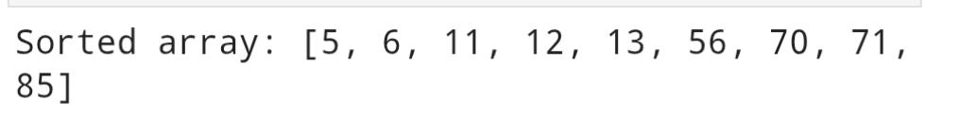
Debugging Questions with Corrected Answers
1 | Debug the following code  Wrong code:  for i in len(arr):  for j in len(arr)-1:  if arr[j] > arr[j+1]:  swap(arr[j], arr[j+1])
OP | Error: ‘int’ object is not iterable  Correct code:for i in range(len(arr)):  for j in range(len(arr) - 1):  if arr[j] > arr[j + 1]:  arr[j], arr[j + 1] = arr[j + 1], arr[j]
2 | Debug the following code  Wrong code:  for i in range(1, arr):  key = arr[i]
OP | Error: list’ object cannot be interpreted as an integer  Correct code:for i in range(1, len(arr)):  key = arr[i]
Conclusion | Bubble Sort, Selection Sort, and Insertion Sort are simple comparison-based sorting techniques. They are easy to understand and suitable for small datasets, but not efficient for large data due to higher time complexity (O(n²)).
Performance Indicators |  | Teachers Dated and Signature
Process Related  (15 M) | Product Related  (10 M) | Total (25 M)

